**NST31042 – Practical for Scaling and Connecting**

Lab Report-9

1. Registration number: SEU/IS/19/ICT/046
2. Academic Year: 2019/2020
3. Practical Number: 9

**Title:** Extended ACL Configuration

**Aim:**

• Extended Named ACL Configuration • Extended Numbered ACL Configuration

**Task:**

• Ip configuration

• Apply the ACL Suitable Interface

• Verify

**Introduction:**

Extended Access Control Lists (ACLs) are a feature of network devices such as routers and switches that allow for granular control over traffic filtering and forwarding decisions based on various criteria, including source and destination IP addresses, port numbers, protocols, and more.

Q1

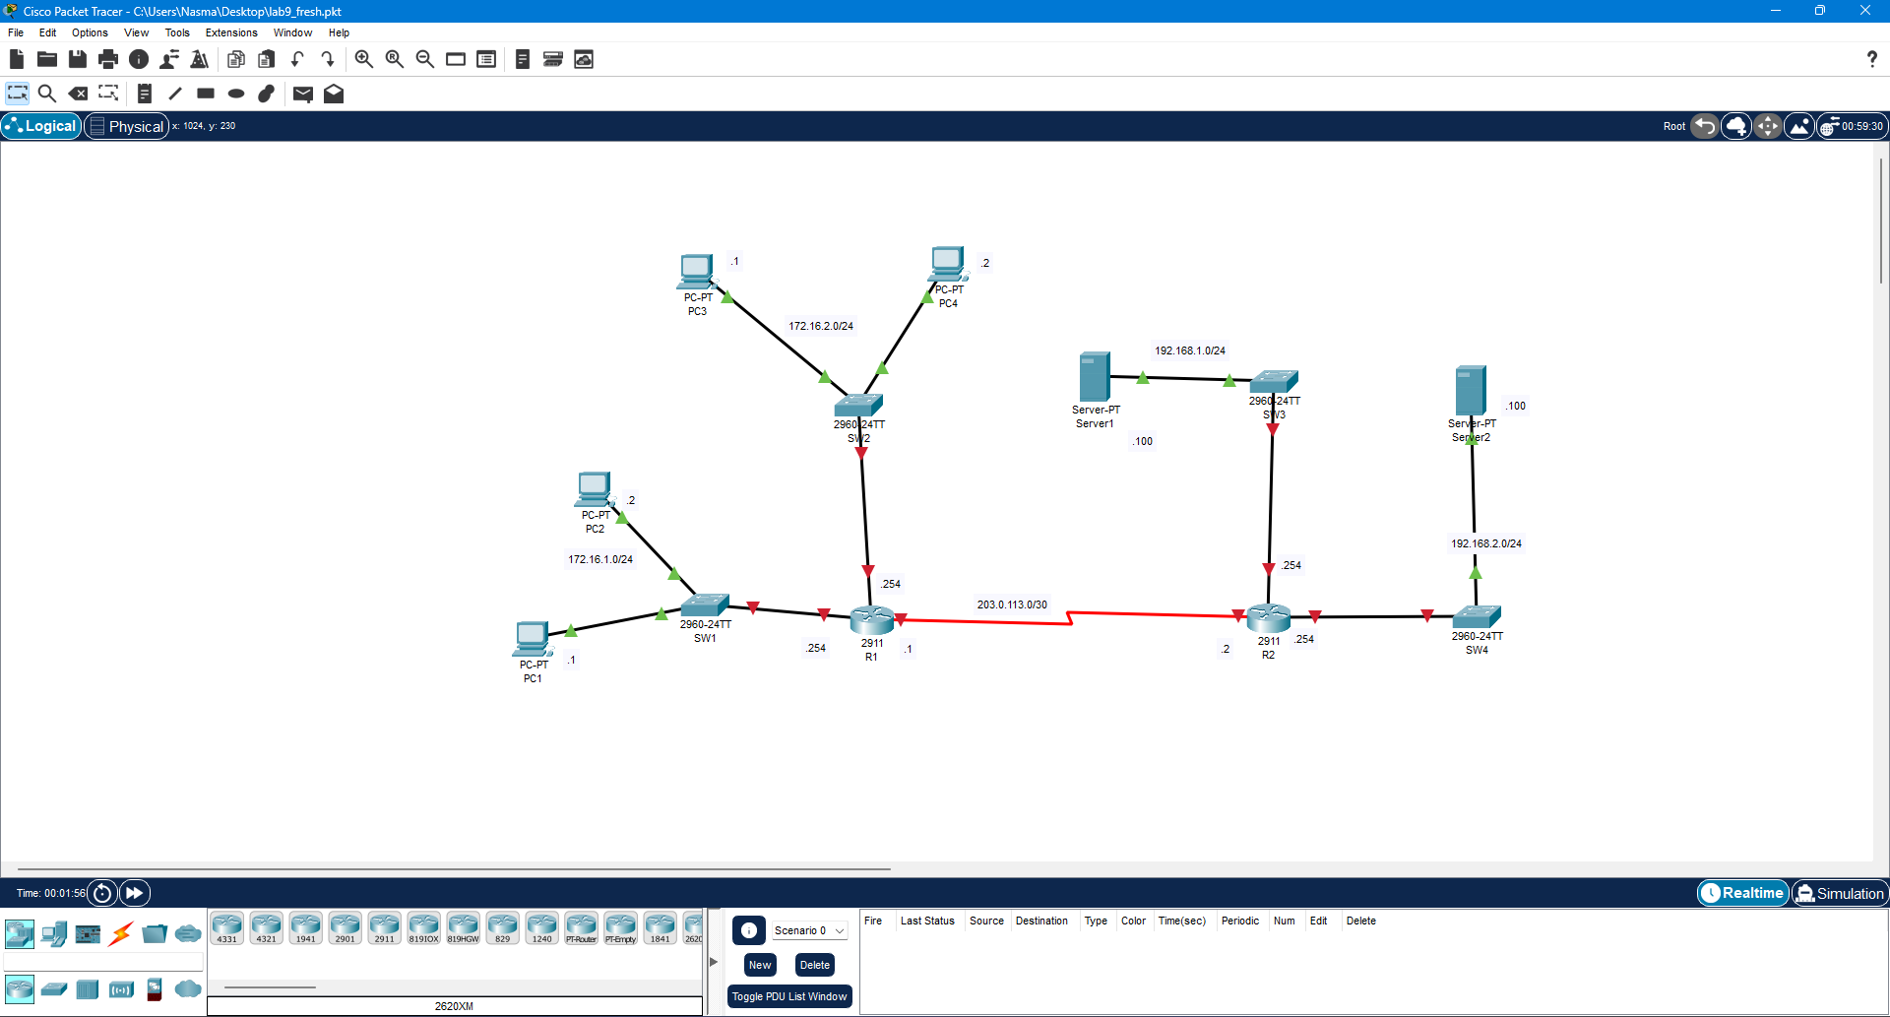

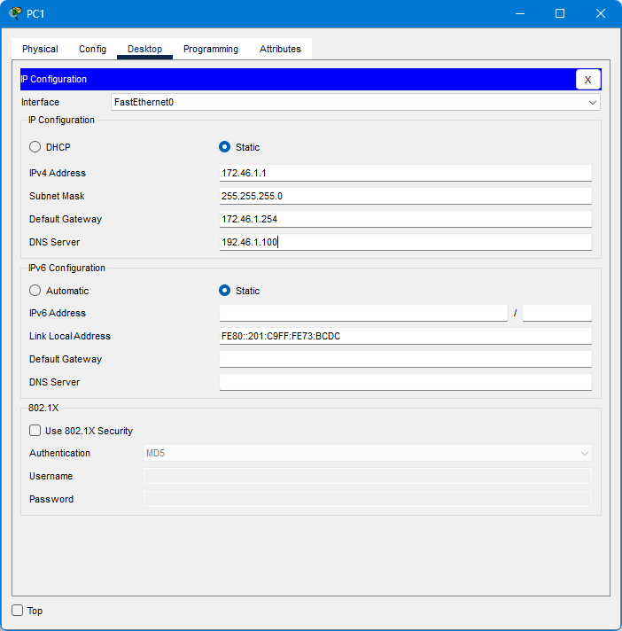

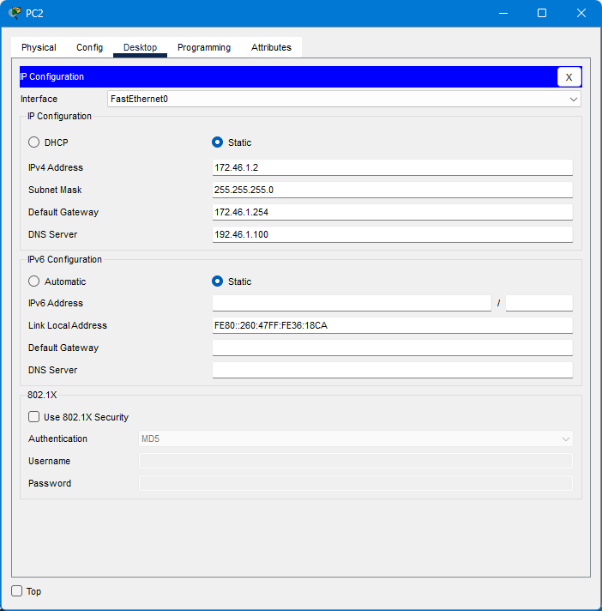

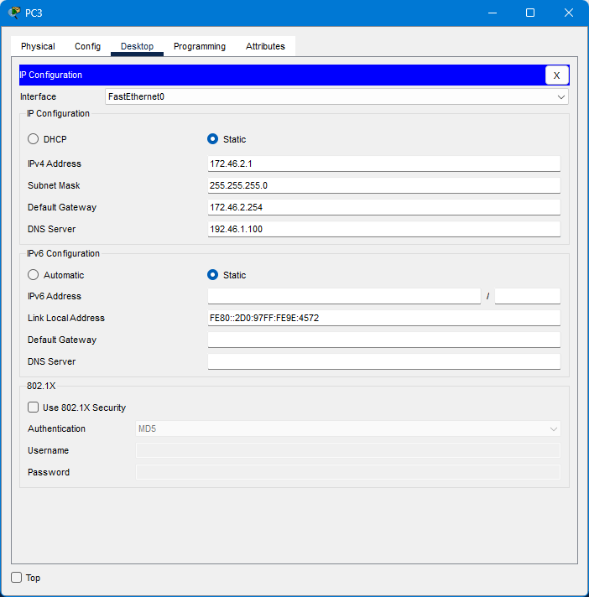

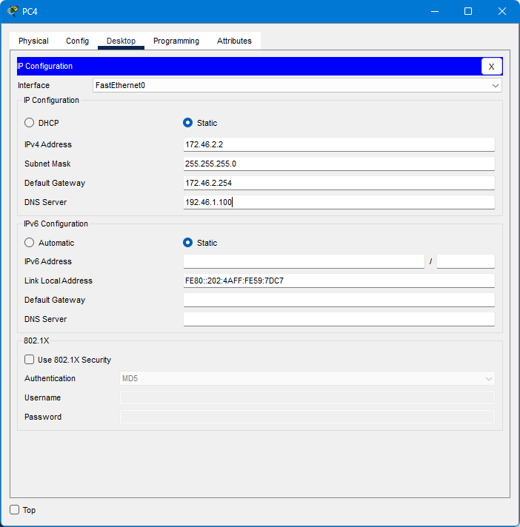

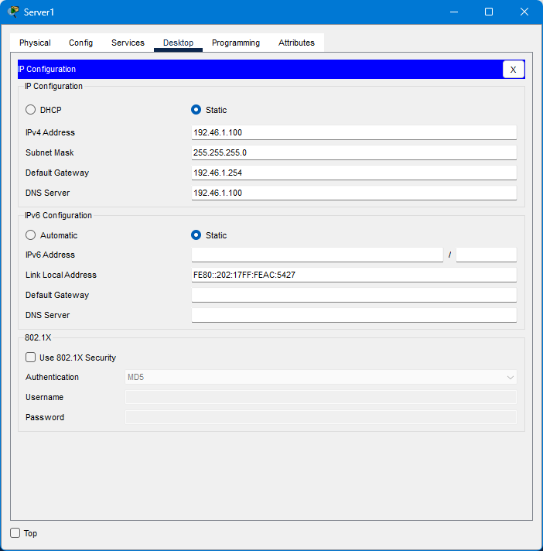

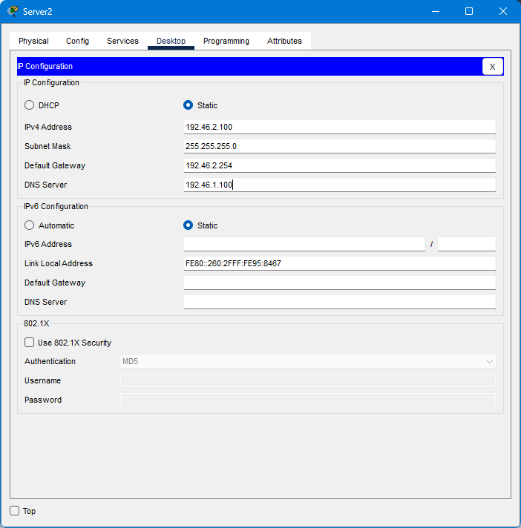

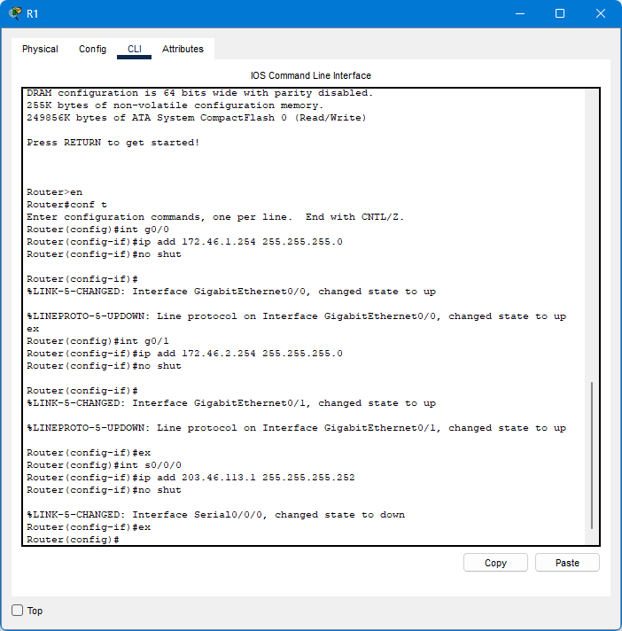

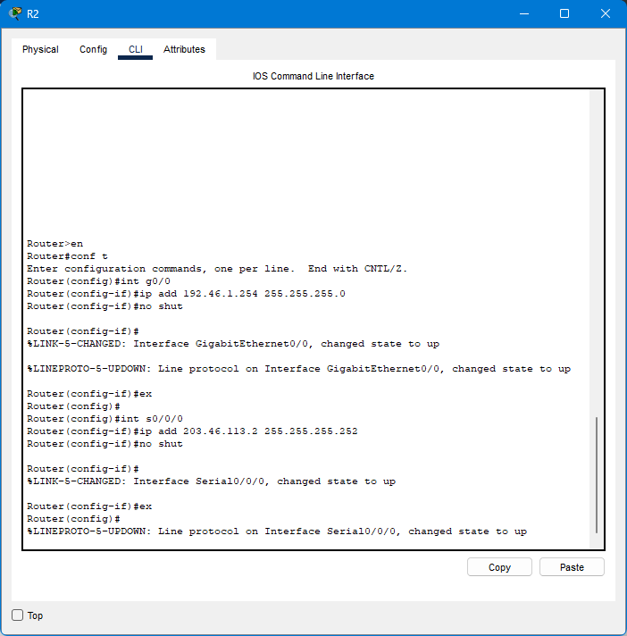

3.Create DNS service in SRV1.

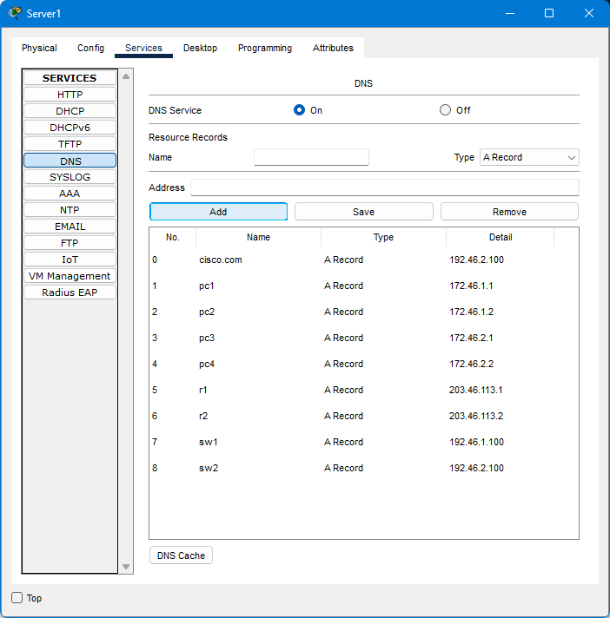

5.Create OSPF in R1 and R2

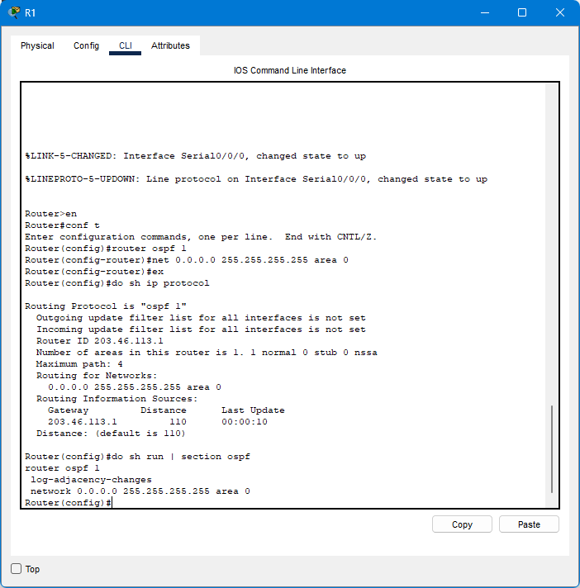

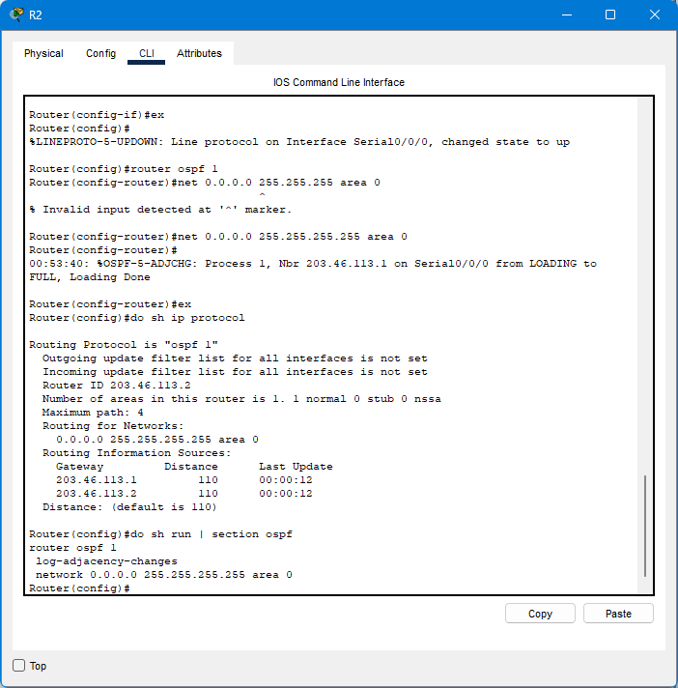

4.Configure extended ACLS to fulfill the following network policies:

-Hosts in 172.16.2.0/24 can’t communicate with PC1

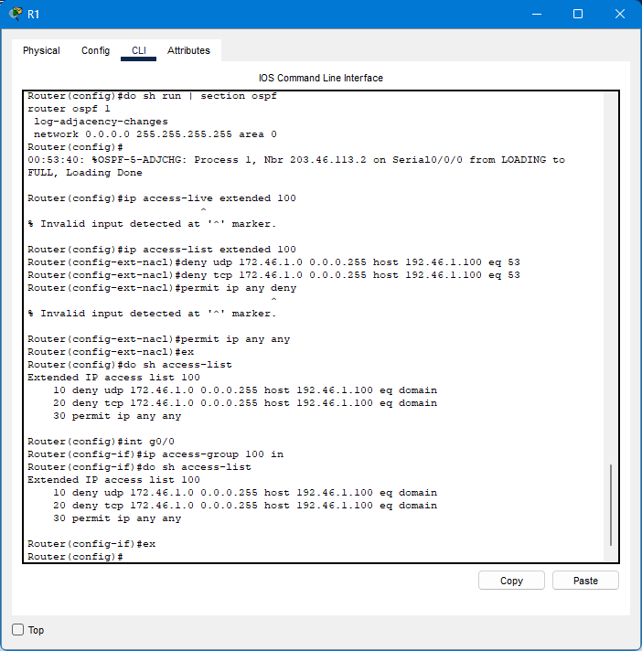

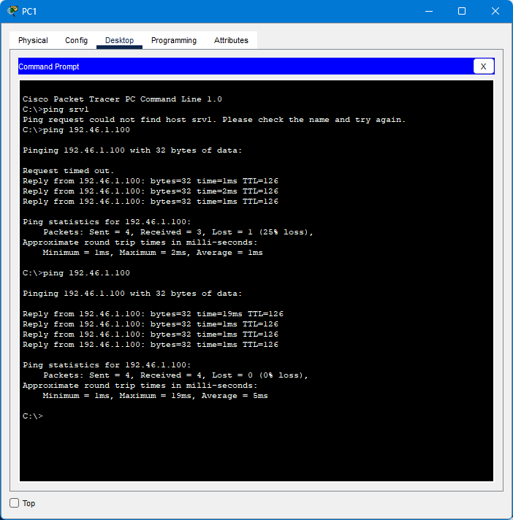

-Hosts in 172.16.1.0/24 cant access the DNS service on SRV1.

-Hosts in 172.16.2.0/24 cant access the HTTP or HTTPS services on SRV2.

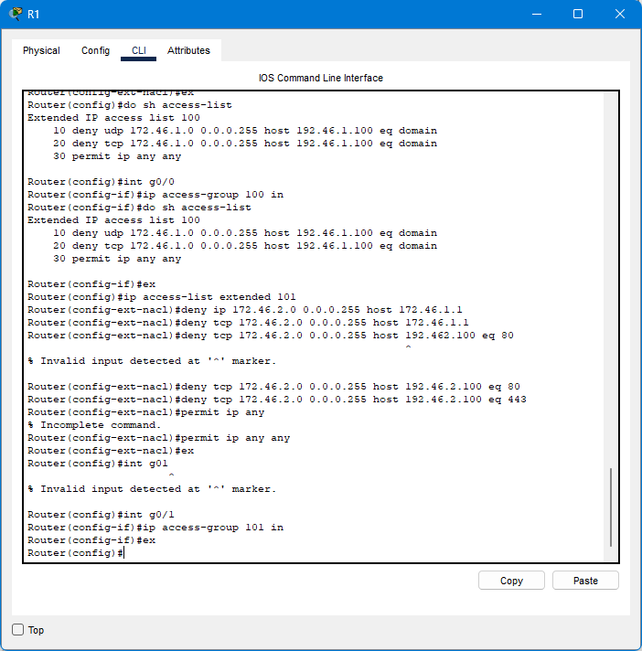

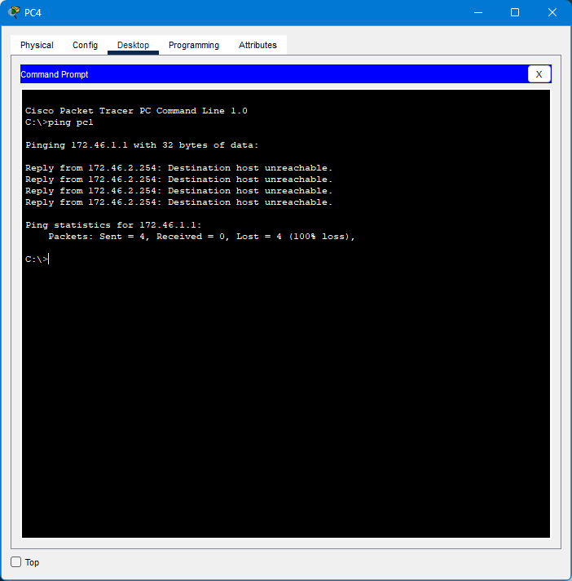

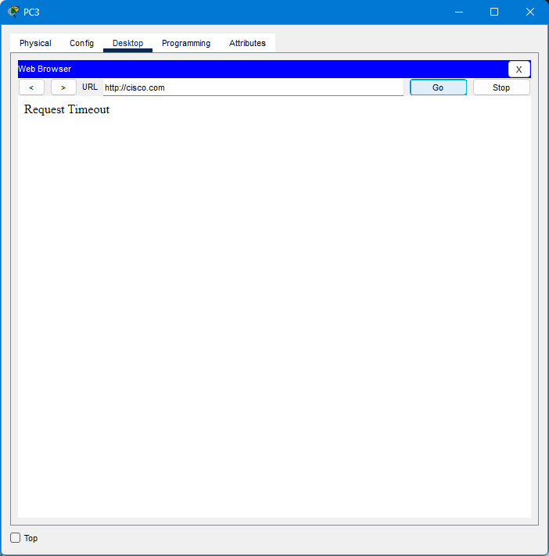

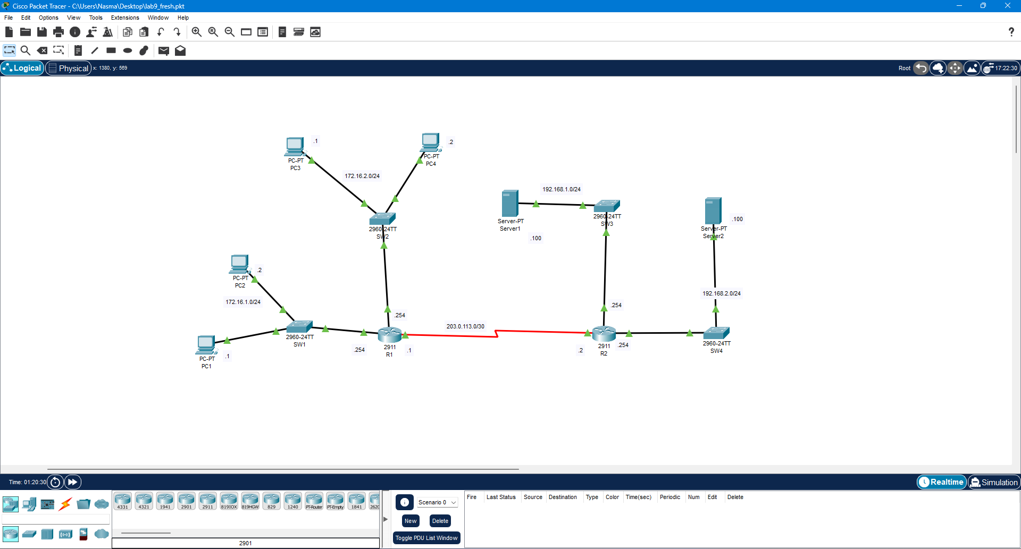

Discussion:

* In this practical session I got the knowledge about Extended Named ACL Configuration and Extended Numbered ACL Configuration
* Access-list (ACL) is a set of rules defined for controlling network traffic and reducing network attacks. ACLs are used to filter traffic based on the set of rules defined for the incoming or outgoing of the network.
* It is one of the types of Access-list which is mostly used as it can distinguish IP traffic therefore the whole traffic will not be permitted or denied like in standard access-list. These are the ACL that uses both source and destination IP addresses and also the port numbers to distinguish IP traffic.

Reference:

* “Extended access-list,” GeeksforGeeks, 11-May-2018. [Online]. Available:

https://www.geeksforgeeks.org/extended-access-list/. [Accessed: 05-Apr-2024].